1. Elevate your user access to root;

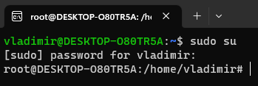

2. add a new user to your Linux OS and set a password for it; 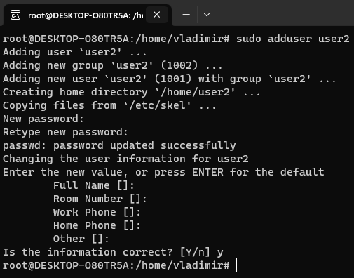

3. Test if you can log in using that user; 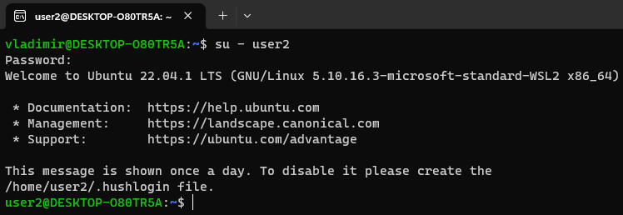

4. Using grep command check if the user is created; 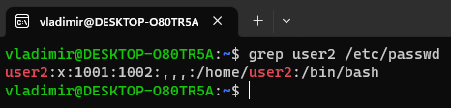

5. grep the UID of each user; 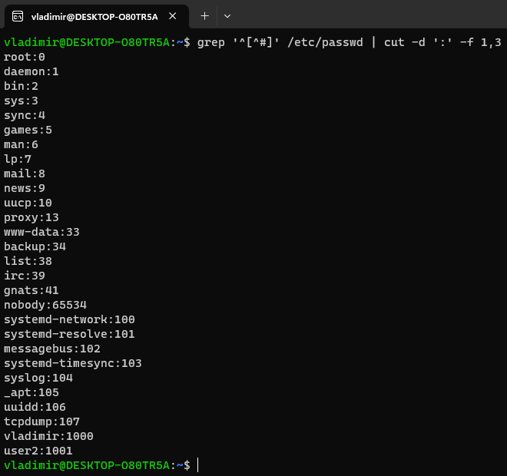

6. Find out the GID of the created user;

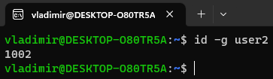

7. Change the password of the user and force it to change the pass on his next login; 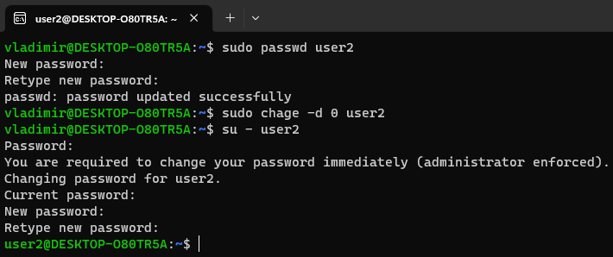

8. Add a new user and set an expiration date for it, with a five-day warning period; 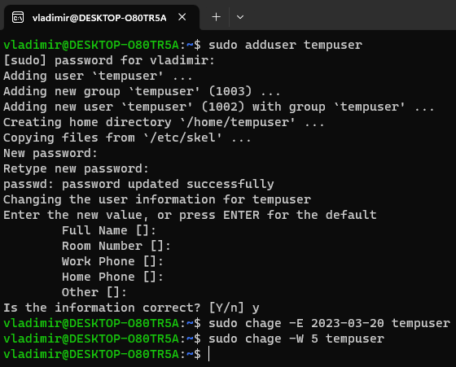

9. Create a new group;

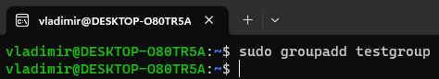

10. Assign the two new users to that group;

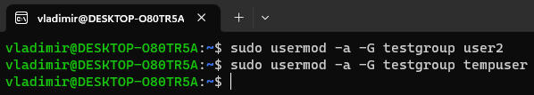

11. Lock one of the user accounts;

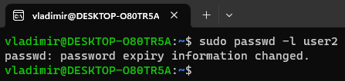

12. Change the shell of one user to tcsh;

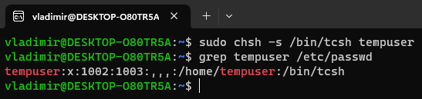

13. Make sure your home directory has “execute” access enabled for group and other.

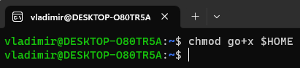

14. Change to your home directory, and create a directory called labs;

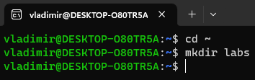

15. Create an empty file in labs directory

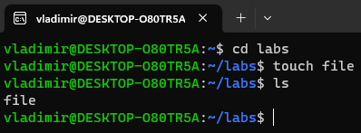

16. Change permissions of file to rwx-rwx-rwx

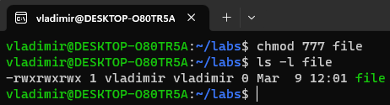

17. List the file. What color is the file? - *GREEN*

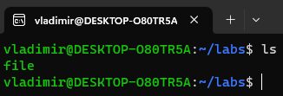

18. Change the permissions back to rx-rw-rw

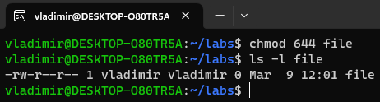

19. Check what owners does the file have.

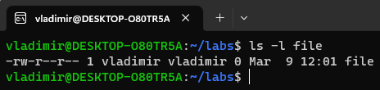

20. Change the user ownership of the file to another user;

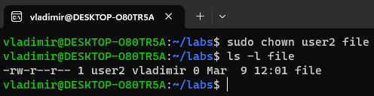

21. Create a group called group1 and assign two users to the group;

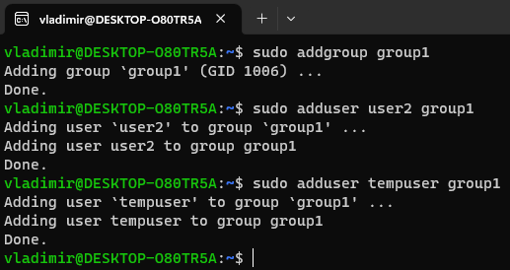

22. Create a file called group1.txt and redirect below input into the file: “This is our group test file”.

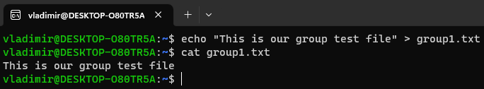

23. Change the group of the file to one of your users;

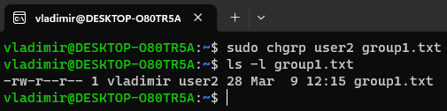

24. Give members of the group group1 read/write access to this file?

